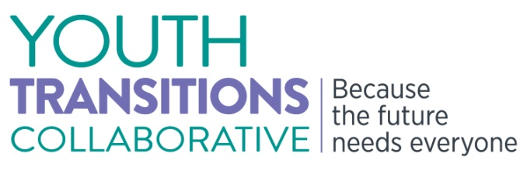
Determined to Succeed:
Preparing for Postsecondary Education
and Employment
Tuesday, December 2, 2014, 2:00pm to 4:00pm
This webinar is designed to inform youth with disabilities, their family members, practitioners, Vocational Rehabilitation (VR) counselors, educators, public and private sector agencies, and other stakeholders about the Office of Special Education and Rehabilitative Services (OSERS) funded Technical Assistance Centers. Rehabilitation Research and Training Centers will also share guidance, tools, and resources on the importance of self-advocacy and transition planning.

AGENDA

2:00 – 2:10 pm Welcome
        - Michael K. Yudin, Acting Assistant Secretary for the Office of Special Education and Rehabilitative Services
        - Jessie MacKinnon, Chief Operating Officer,
National Youth Transitions Center

2:10 – 2:35 pm Transitions Research and Training Center (Transitions RTC)
University of Massachusetts Medical School
        - Maryann Davis, Ph.D., Project Director
        - Jennifer Whitney, Research Technician Assistant

2:35 – 2:55 pm Center for Parent Information and Resources
@Statewide Parent Advocacy Network
        - Debra A. Jennings, Director

2:55 – 3:20 pm TransCen, Inc.
        - Laura Owens, Ph.D., CESP, Incoming Executive Director
        - Kelli Crane, Ph.D., Senior Research Associate

3:20 – 3:45 pm National Technical Assistance Center on Improving Transition to Postsecondary Education and Employment for Students with Disabilities
University of North Carolina at Charlotte
- David Test, Ph.D., Project Director

3:45 – 4:00 pm Closing Today’s Collaboration: Questions and Reflections
- Sue Swenson, Deputy Assistant Secretary, Office of Special Education and Rehabilitative Services

